High Wolds Heritage Group Christmas Social
December 10th 2009
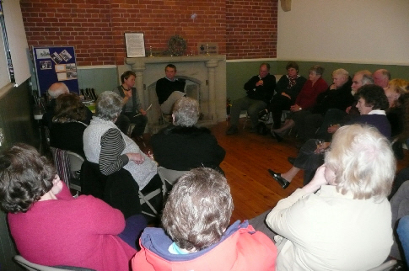
Twenty-four people attended this event. We were pleased to welcome some new faces and a guest speaker, Ingrid Barton.
The business part of the meeting was concerned with the forthcoming ‘War Time on the Wolds’ Exhibition which will be held at Sledmere on June 26/27 2010. A short period of discussion produced many ideas about what might be included in the exhibition. (See list below.)
A performance of a play, ‘Land Girls’ has been arranged for May 19th. Venue to be arranged.
People were asked to think about any particular subject areas that they would like to research for the exhibition as well as gathering information about their own villages and other villages on the Wolds. We will not limit the geographical area for the exhibition to the High Wolds.
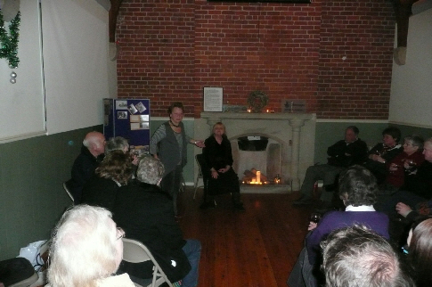
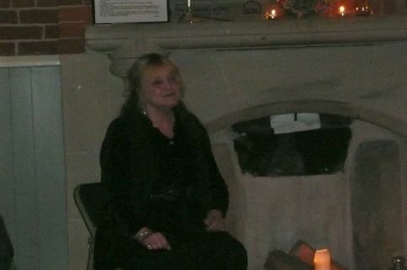
After refreshing our glasses with mulled wine we settled down to enjoy an entertaining half hour of story time. Ingrid, a professional story teller, explained that the East Riding has very few traditional stories unlike some parts of the country but she had an authentic tale from Willey Howe near Wold Newton about a ‘Fairy Cup’. Her second story was linked to the chariot burial at Wetwang. The woman in the burial is known to have had a large ‘strawberry mark’ or birthmark and it was believed that a woman with this type of mark had special powers and perhaps that is why the ‘red woman’ was given such a significant burial. Everyone was thoroughly absorbed by the stories and by Ingrid’s expressive presentation and said how rare it is to hear a story rather than reading one and what an enjoyable experience it had been.

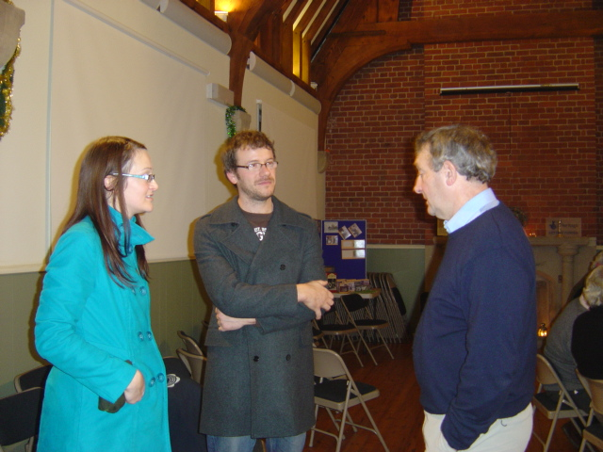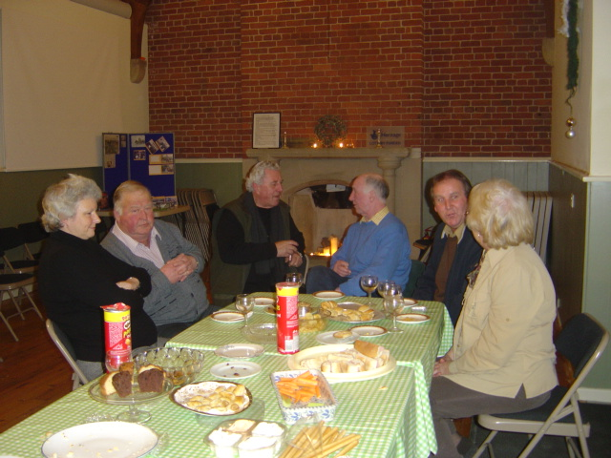
‘The chair in recruitment mode!’ ‘The remains of the day or leftovers!’
Ideas for the War Time on the Wolds Exhibition.
Local incidents: bombs plane crashes parachutists
Evidence of wartime activities: pill boxes buildings
Prisoners of war camps
Tank Training grounds
Airfields and dummy airfields
Sykes war memorial inscriptions
Impact on farming
The home front
The Home Guard
The Observer Corps
The Land Army
The Free French
Uniforms, medals and other memorabilia
Oral history – recordings of wartime memories
The secret army
Evacuees
Possible sources of information: Eden Camp, WW2 exhibition Centre, newspaper archives, National Film Archive, Elvington Air Museum, people in the community, experts, books, tapes.

